# How Content Marketing Helps Your Business Grow

In today's digital world, **content marketing** is key for business growth. Savvy entrepreneurs know that smart **blog writing** and SEO can change how companies meet customers. By sharing valuable info, businesses can draw in, keep, and engage audiences better than ads.

**Content marketing** is more than just promoting. It's about making real connections with your audience by offering real value. With well-made content, companies can show they're experts, build trust, and solve problems for their customers.

Good **content marketing** uses many ways to reach and affect potential clients. It can be through blog posts, social media, or special guides. The aim is always the same: to share top-notch content that meets your audience's needs and interests.

### Key Takeaways

* Content marketing creates deeper customer connections
* Strategic **blog writing** drives organic traffic
* **SEO content** helps improve online visibility
* Quality information builds brand trust
* Consistent content develops long-term audience relationships

## Understanding the Fundamentals of Content Marketing Strategy

Creating a solid content marketing strategy is key to digital success. Businesses that focus on content marketing can boost their online image. They can also connect deeply with their audience.

Building a good content marketing plan needs careful thought and strategy. The right plan helps companies make content that draws in and keeps customers. It also helps grow the business.

### Defining Your Content Marketing Goals

Good **SEO content** starts with clear goals. Think about these main goals for your content marketing:

* Increase brand awareness
* Generate qualified leads
* Improve customer engagement
* Drive website traffic
* Establish thought leadership

### Identifying Target Audience Personas

Knowing your audience is key in content marketing. Create detailed personas that include:

| Persona Element | Key Details to Include |
| --- | --- |
| Demographics | Age, location, income, education |
| Behavioral Traits | Online habits, content preferences |
| Pain Points | Challenges and needs |
| Goals | Professional and personal objectives |

### Creating a Content Calendar

A content calendar helps keep your content consistent and on track. *Organize your content marketing efforts* by planning topics, dates, and channels ahead of time.

"Planning is bringing the future into the present so you can do something about it now." - Michael Vance

By using these basic strategies, businesses can make a strong content marketing plan. This plan will speak to their audience and increase engagement.

## The ROI of Content Marketing in Modern Business

https://www.youtube.com/watch?v=j1CNmi302Oc

Businesses are finding out how powerful content marketing can be. By looking at the return on investment (ROI), they see how it helps their business grow. It brings real economic benefits.

Good content marketing brings value in many ways:

* It cuts down on the cost of getting new customers
* It makes your brand more visible
* It boosts how much customers interact with your brand
* It leads to more sales

Companies that invest in **blog writing** and content marketing get big returns. Digital marketing pros say content marketing gets about *3x more leads* than old-school ads.

"Content marketing is not just about creating content, but creating value for your audience and your business." - Content Strategy Expert

Now, let's look at some numbers that show how well content marketing works:

| Marketing Channel | Average ROI | Lead Generation |
| --- | --- | --- |
| Content Marketing | 574% | High |
| Traditional Advertising | 167% | Low |
| Social Media Marketing | 284% | Medium |

Both small and big businesses can use content marketing to grow. By making content that really speaks to their audience, they can get real results.

## Building Brand Authority Through Quality Content

Content marketing is a strong tool for making your brand credible and known online. By making smart **SEO content**, businesses can change from just being there to being leaders in their field.

Successful brands know content marketing is more than just promoting. It's about making real connections with people through useful, insightful info.

### Establishing Thought Leadership

To be seen as a thought leader, follow these steps:

* Make deep, research-based content
* Share unique insights in your field
* Offer solutions to big problems
* Show your expertise with case studies

### Creating Trust-Building Content

Trust is key for a strong brand relationship. Your SEO content should be open, real, and valuable.

"Content builds relationships. Relationships build trust. Trust drives revenue." - Andrew Davis

### Developing a Consistent Brand Voice

A clear brand voice helps people recognize and connect with your content everywhere. Think about these things:

| Brand Voice Element | Key Characteristics |
| --- | --- |
| Tone | Professional, friendly, authoritative |
| Language | Clear, concise, right for your audience |
| Messaging | Always the same core values and mission |

By using these strategies, your content marketing will draw in people and build trust in your field.

## Driving Organic Traffic Through SEO-Optimized Content

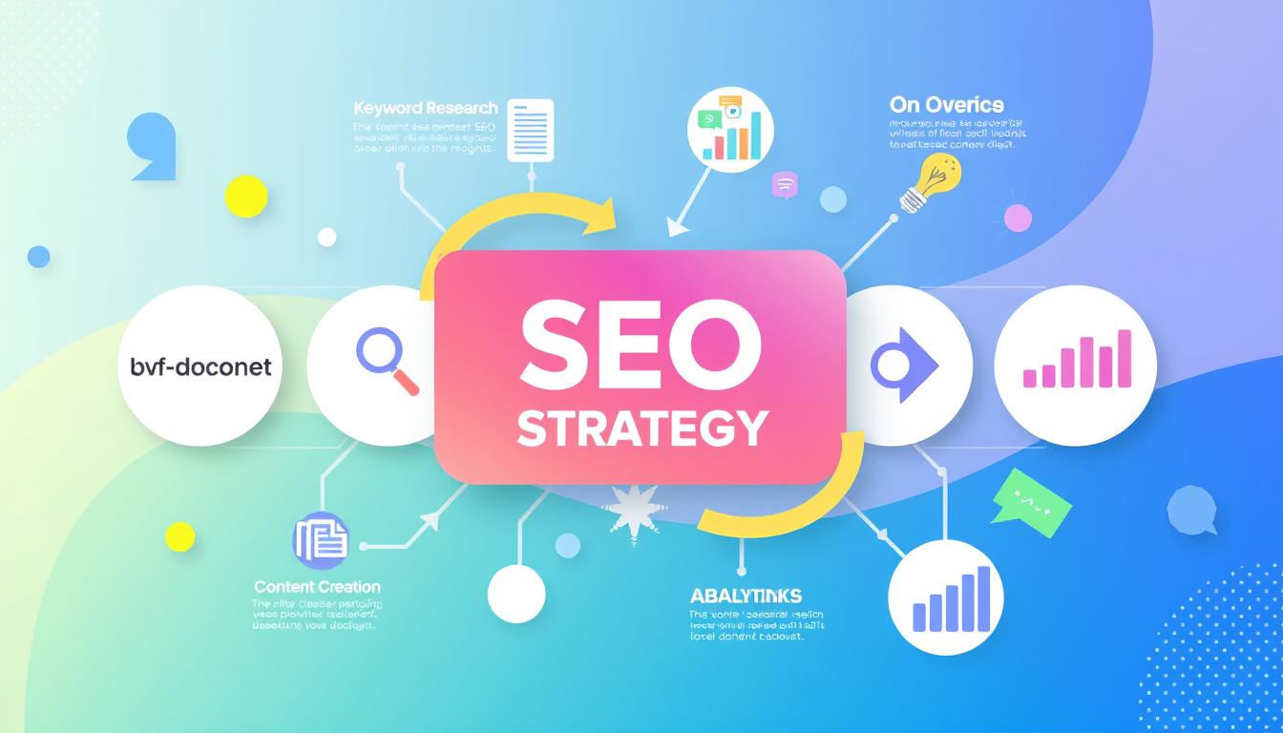To attract organic traffic, you need a solid SEO content plan. It's not just about adding keywords. It's about creating content that truly engages readers and search engines.

"Great SEO content speaks both to search engines and human readers simultaneously."

Creating effective SEO content involves several key steps:

* Conduct thorough keyword research using advanced tools
* Understand user search intent
* Create high-quality, original content
* Optimize on-page elements
* Implement strategic internal linking

Keyword research is the base of good SEO content. *Digital marketers must find search terms with good volume and competition*. This helps make content that meets audience needs and boosts search visibility.

| SEO Content Strategy | Key Focus Areas |
| --- | --- |
| Keyword Research | Identify relevant search terms |
| Content Quality | Create valuable, original information |
| Technical Optimization | Improve page structure and meta elements |
| User Experience | Ensure readability and engagement |

Search engines value content that shows expertise and trust. By making high-quality SEO content, businesses can climb the search rankings. This brings more targeted visitors to their site.

## Content Marketing, Blog Writing, SEO Content: The Perfect Trio

Digital marketing success comes from combining content marketing, blog writing, and SEO content. These elements form a strong strategy. It boosts engagement, visibility, and growth for businesses.

Today, businesses need a smart plan for digital content to boost their online presence. The mix of content marketing, blog writing, and SEO content is key. It helps reach and convert target audiences effectively.

### Integration Strategies for Maximum Impact

For successful content integration, a multi-dimensional approach is needed:

* Align blog writing with targeted SEO keywords
* Create content that addresses specific audience pain points
* Develop a consistent brand narrative across all platforms

"Content marketing is no longer about creating content, but about creating value for your audience."

### Measuring Content Performance

It's vital to track content effectiveness for ongoing improvement. Key metrics include:

1. Organic traffic growth
2. Engagement rates
3. Conversion metrics
4. Social media shares

### Optimizing Content Distribution

Effective content distribution widens your message's reach. *Strategic platforms and targeted sharing* are crucial. They help expand your content's impact.

By blending content marketing, blog writing, and SEO content, businesses can craft a strong digital marketing plan. This plan connects with audiences and drives significant results.

## Converting Readers into Loyal Customers

https://www.youtube.com/watch?v=LQ3OTKch6iU

Content marketing turns casual readers into loyal customers through strategic engagement. Blog writing is more than just interesting articles. It's about building meaningful connections that guide potential clients through their purchasing journey.

"Great content is the best sales tool in the world" - Marcus Sheridan

Successful content marketing starts with understanding your audience's needs and pain points. Creating targeted content that speaks directly to potential customers builds trust and credibility.

* Create personalized content experiences
* Design clear conversion pathways
* Use strategic calls-to-action
* Develop content for each buyer journey stage

The conversion process involves carefully crafted content marketing strategies that nurture leads. *Potential customers want valuable information before making purchasing decisions*.

| Content Type | Conversion Potential | Engagement Level |
| --- | --- | --- |
| Blog Posts | Medium | High |
| Case Studies | High | Very High |
| Webinars | High | Medium |

By using these content marketing techniques, businesses can guide readers from initial interest to loyal customer status. The key is providing genuine value throughout their decision-making process.

## Creating Engaging Content That Resonates with Your Audience

To grab your audience's attention online, you need more than just text. Good content marketing turns simple info into stories that connect with people.

### Storytelling Techniques in Content Marketing

Storytelling makes SEO content come alive, linking brands to their audience. It turns hard ideas into stories that readers can relate to.

* Use personal anecdotes to humanize your brand
* Develop character-driven narratives
* Create conflict and resolution within your content
* Highlight real customer experiences

### Visual Content Integration

Adding visuals makes content marketing better. Infographics, videos, and images share complex ideas in a simple way.

"A picture is worth a thousand words" - this is true in digital content marketing

### Interactive Content Strategies

Good content marketing is interactive. It makes readers do more than just read. It turns them into active participants.

1. Design quizzes related to your industry
2. Create interactive calculators
3. Develop assessment tools
4. Implement polls and surveys

Using these methods, brands can make SEO content that really speaks to their audience.

## Leveraging Social Media to Amplify Content Reach

Social media has changed content marketing a lot. It gives businesses great ways to share their blog writing and digital presence. Now, good content marketing needs a strong social media plan, not just posting.

Here are some key ways to get your content seen more:

* Tailoring content to fit each social media platform
* Making special visual assets for each platform
* Talking directly with people who comment and interact
* Using special features like stories, reels, and live streams

Every social media site needs its own content style. *LinkedIn likes professional, industry-related content*. Instagram loves pictures and stories that tell a story. Twitter is all about quick, engaging messages.

"Social media isn't just about broadcasting—it's about building genuine connections through strategic content marketing." - Marketing Experts

To share content well on social media, you need a plan:

| Platform | Content Type | Engagement Strategy |
| --- | --- | --- |
| Facebook | Long-form articles, videos | Community building, targeted ads |
| Instagram | Visual storytelling, infographics | Stories, hashtag campaigns |
| Twitter | Short insights, blog teasers | Quick interactions, trending topics |

By knowing each platform's special features, businesses can turn their content marketing into real audience connections.

## Content Marketing Analytics and Performance Tracking

It's key to track your content marketing strategy's performance for growth. Insights from data help businesses see what works and improve their SEO content.

Success in content marketing isn't just about numbers. Marketers must dig into analytics to really grasp their content's effect.

### Key Metrics to Monitor

* Website Traffic
* Engagement Rate
* Conversion Rate
* Time on Page
* Social Media Shares

### Tools for Content Analysis

| Tool | Primary Function | Cost |
| --- | --- | --- |
| Google Analytics | Comprehensive Web Performance Tracking | Free |
| SEMrush | SEO Content Performance Analysis | Paid |
| Ahrefs | Keyword and Backlink Monitoring | Paid |

### Adjusting Strategy Based on Data

*Successful content marketing requires continuous refinement*. By regularly analyzing performance metrics, businesses can:

1. Identify top-performing content
2. Understand audience preferences
3. Optimize underperforming content
4. Allocate resources more effectively

"In the world of digital marketing, data is your most powerful ally." - Marketing Expert

Using data to guide your content marketing keeps your strategy sharp, relevant, and in tune with what your audience wants.

## Cost-Effective Marketing Through Content Creation

https://www.youtube.com/watch?v=4XrtVkhOBfQ

Content marketing is a smart and affordable way for businesses to reach their audience. Small and medium-sized companies can use blog writing and content strategies without spending a lot.

Creating smart content can cut down marketing costs while bringing in big returns. With a good content plan, businesses can stretch their marketing budget further.

* Repurpose existing content across multiple channels
* Create evergreen blog writing pieces
* Develop scalable content templates
* Utilize free design and editing tools

"Content marketing costs 62% less than traditional marketing and generates approximately three times as many leads." - Content Marketing Institute

The secret to affordable content marketing is in planning and using resources wisely. *Quality always trumps quantity* when making content that speaks to your audience.

Digital platforms offer cheap ways to share your content. Social media, email newsletters, and search engines can help spread your message without costing a lot.

| Strategy | Cost | Potential Reach |
| --- | --- | --- |
| Blog Writing | Low | High |
| Social Media Content | Very Low | Very High |
| Video Content | Medium | High |

By using these budget-friendly content marketing methods, businesses can grow their brand, connect with customers, and increase growth without spending a lot.

## Long-Term Benefits of Consistent Content Marketing

Content marketing is a strong strategy for businesses to connect with their audience. It's not just about making content. It's about creating a valuable digital asset that grows over time.

Success in content marketing needs patience and dedication. It's about creating valuable SEO content that speaks to your audience.

### Building a Content Library

Building a content library is like creating a digital knowledge vault for your brand. Each piece of content adds value and serves many purposes:

* Provides ongoing educational resources for customers
* Improves website search engine rankings
* Establishes brand credibility
* Generates passive organic traffic

### Compounding Returns Over Time

Content marketing offers *compounding returns* like financial investments. Quality content keeps generating value long after it's first published.

| Content Type | Initial Investment | Long-Term Value |
| --- | --- | --- |
| Blog Posts | $250 | $1,500+ annually |
| In-depth Guides | $1,000 | $5,000+ annually |

### Establishing Industry Authority

"Consistent content creation is the cornerstone of thought leadership in digital marketing." - Marketing Experts

By sharing insights, research, and valuable information regularly, brands become trusted experts. SEO content that shows deep knowledge attracts more engaged audiences and builds credibility over time.

## Conclusion

Content marketing is a strong way for businesses to grow online. It combines blog writing, SEO content, and smart communication. This helps companies improve their online image and connect better with people than old-school ads.

To succeed in content marketing, you need to keep working hard and plan well. Brands that really get to know their audience and make valuable content will see big benefits. Remember, content is an ongoing chat with possible customers, not just a one-time thing.

The digital world keeps changing, and content marketing is key for businesses to stay ahead. Whether you're new or already established, using SEO content can make your brand stand out. It builds trust and leads to real business results.

Your content marketing journey begins with knowing what makes you special and telling stories that hit home with your audience. Stay flexible, use data, and focus on giving real value. This way, you'll build a strong digital marketing plan that helps your business grow for the long haul.

## FAQ

### What exactly is content marketing?

Content marketing is about making and sharing useful content to attract and keep an audience. It aims to provide helpful info that solves problems or entertains. This approach drives customers to take action.

### How often should I publish blog content?

The best posting frequency varies by your resources and audience. Most businesses aim for 1-4 posts a week. Being consistent is key, not how much you post. Quality is more important than quantity.

### How long does it take to see results from content marketing?

Content marketing takes time. Results usually show up in 6-12 months. This can change based on your industry, content quality, and how you share it.

### Do I need a big budget to start content marketing?

No, you don't need a lot of money to start. You can use what you know and free tools like Google Analytics. Sharing on social media is also free.

### How do I know if my content marketing is working?

Look at website traffic, engagement, social shares, and lead generation. Google Analytics can help track your content's impact. This shows what's working and what needs improvement.

### What types of content work best for marketing?

Effective content includes blog posts, videos, infographics, podcasts, and more. The best mix depends on your audience and goals.

### How important is SEO in content marketing?

SEO is very important. It helps your content be found by search engines. This increases visibility and drives traffic. Use keywords, create quality content, and follow SEO tips to reach more people.

### Can content marketing work for any type of business?

Yes, it can! Every business can benefit from content marketing. The key is to know your audience and offer them real value.

### How do I develop a content marketing strategy?

Begin by setting goals and understanding your audience. Create personas and a content calendar. Track your progress with key metrics. Make content that meets your audience's needs.

### What's the biggest mistake in content marketing?

The biggest mistake is making content without a clear purpose or audience understanding. Successful content marketing needs planning, knowing your audience, and delivering valuable content.